Appendix C: IEEE 830 Template
Software Requirements Specification
for
Library system
Version 4
Prepared by Maksymilian Kościelniak
13.04.2026
«Page Break»
Table of Contents
«Table of Contents»
Revision History
Name | Date | Reason for Changes | Version
Maksymilian Kościelniak | 27.04.2026 | Completed missing sections and functional requirements | 5
Maksymilian Kościelniak | 13.04.2026 | New diagrams added | 4
Maksymilian Kościelniak | 23.03.2026 | New data - UML | 3
Maksymilian Kościelniak | 14.03.2026 | New data - UML | 2
Maksymilian Kościelniak | 03.03.2026 | Initial version | 1
«Page break»
1. Introduction
1.1. Purpose
The purpose of this document is to describe the requirements for the Library system, Version 1. This document explains what the Library system should do and how it should work. It describes the main functions of the system, such as managing books, users, borrowing, and returning books. The scope of this specification includes the basic features needed for a simple library management system. This document will be used as a guide during the development of the system.
1.2. Document Conventions
This document uses simple and clear language to describe the system requirements. All requirements are written in a clear form using the word “shall” to show what the system must do. Each requirement is numbered so it is easy to find and refer to later. Headings and section numbers are used to organize the document and make it easier to read.

1.3. Intended Audience and Reading Suggestions
This document is for developers, testers, and the project supervisor. Developers should read the whole document. Testers should focus on the requirements. It is best to read the document from the beginning to understand the system step by step.
1.4. Product Scope
The Library system is a software application used to manage a library. It helps store information about books and users. The system allows adding books, registering users, borrowing books, and returning them. Its main goal is to make library management easier and more organized.
1.5. References
IEEE Recommended Practice for Software Requirements Specifications (IEEE Std 830-1998).
2. Overall Description
2.1. Product Perspective
The Library system is a new software application created as part of a university project. It is an independent system and is not connected to any existing library software. The system is designed to manage books and users in a digital way instead of using paper records. It will help organize information about books, borrowing, and returning in a simple and structured way.
2.2. Product Features
The main features of the Library system are:
- Adding new books to the system
- Removing books from the system
- Registering new users
- Borrowing books
- Returning books
- Viewing the list of available books
2.3. User Classes and Characteristics
- Reader: The end-user of the system. Their main goal is to browse available books, borrow them, and return them. Requires a simple and intuitive interface.
- Librarian: The system administrator. Has permissions to manage the database (add/remove books) and register new users.
2.4. Operating Environment
The system operates as an independent web application. It requires a standard web browser on the client side and a server with a database on the backend to manage digital records.
2.5. Design and Implementation Constraints
- Developed as a university project.
- Must rely on standard web technologies (e.g., Java/Python, relational database).
- Must ensure strict data consistency, as it replaces traditional paper records.

2.6. User Documentation
- In-app tooltips and a brief, built-in help section for Readers.
- A concise technical guide and setup manual for Developers.
2.7. Assumptions and Dependencies
- Users must have an active internet connection to access the system.
- The application functions independently and does not require integration with any external or third-party library software.
3. System Features
3.1. User Account Management
The system allows users to log in, log out, and register new accounts.
3.2. Book Inventory Management
The system allows the Librarian to add new books to the database and remove old or lost books.
3.3. Borrowing and Returning Books
The system allows Readers to borrow available books and return them later, tracking the due dates and potential fines.4. External Interface Requirements
4.1. User Interfaces Overview
The system will use a graphical web interface (GUI). It will be easy to use and navigate. Readers will see a main screen with a search bar and a list of available books. Librarians will have a special dashboard with buttons like "Add Book" or "Manage Users". The interface will use simple buttons and forms. If a user makes a mistake (like typing the wrong password), the system will show a clear error message in red text.
4.2. Hardware Interfaces
The system does not need any special hardware to work. It will run on standard personal computers, laptops, and mobile devices. A normal internet connection is required to communicate with the web server.
4.3. Software Interfaces
The system will connect to a relational database (like MySQL or PostgreSQL) to store information about books, users, and loans. The user interface will be displayed in standard web browsers (such as Google Chrome, Firefox, or Safari).
5. System Features/Modules
5.1. Borrow a Book
5.1.1 Description and Priority
This feature allows a Reader to borrow a book from the library. Priority: High.
5.1.2 Stimulus/Response Sequences
- Condition: The user clicks the "Borrow" button next to an available book.
- Response: The system registers the loan, calculates the due date, and updates the book's status to "Borrowed".
5.1.3 Functional Requirements
- REQ-1.1: The system shall allow a Reader to borrow a book only if they have an "Active" account state.
- REQ-1.2: The system shall block borrowing if the user has unpaid overdue fines.
- REQ-1.3: The system shall change the book's availability status to "false" after a successful borrow action.
5.2. Add a New Book
5.2.1 Description and Priority This feature allows a Librarian to add a new book to the database. Priority: High.
5.2.2 Stimulus/Response Sequences
- Condition: The Librarian fills out the "New Book" form and clicks "Save".
- Response: The system saves the data in the database and shows a "Book added successfully" message.
5.2.3 Functional Requirements
- REQ-2.1: The system shall allow only users with the "Librarian" role to add books.
- REQ-2.2: The system shall require the Librarian to provide the book's title, author, and ISBN before saving.
6. Nonfunctional Requirements

6.1. Performance
- NF-1.1: The system shall load pages in under 3 seconds on a standard internet connection.
- NF-1.2: The database shall support at least 50 users working on the system at the same time without slowing down.
6.2. Security
- NF-2.1: The system shall encrypt all user passwords before saving them in the database.
- NF-2.2: The system shall automatically log out any user after 30 minutes of inactivity to protect their account.

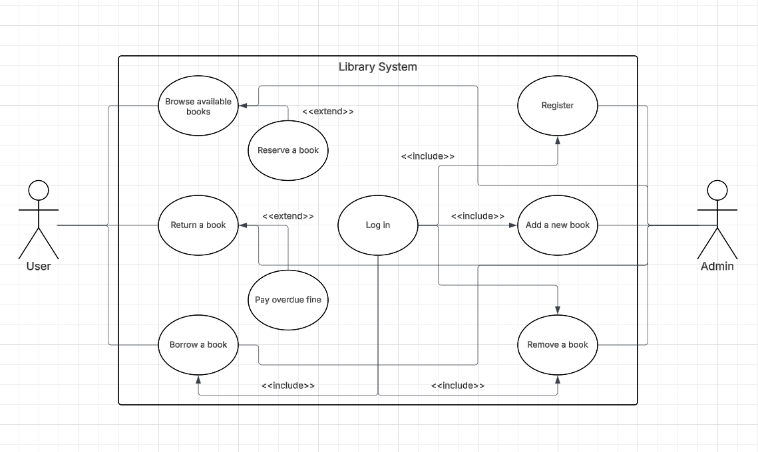
This Use Case Diagram illustrates the main interactions between external actors and the Library System. It identifies two primary actors: the User (Reader) and the Admin (Librarian). The User can browse, borrow, and return books, while extending their actions to reserve books or pay overdue fines when necessary. The Admin is responsible for system management tasks, such as adding or removing books and registering new accounts. Central to many of these actions is the "Log in" use case, which is included as a mandatory step for borrowing books and performing administrative tasks.
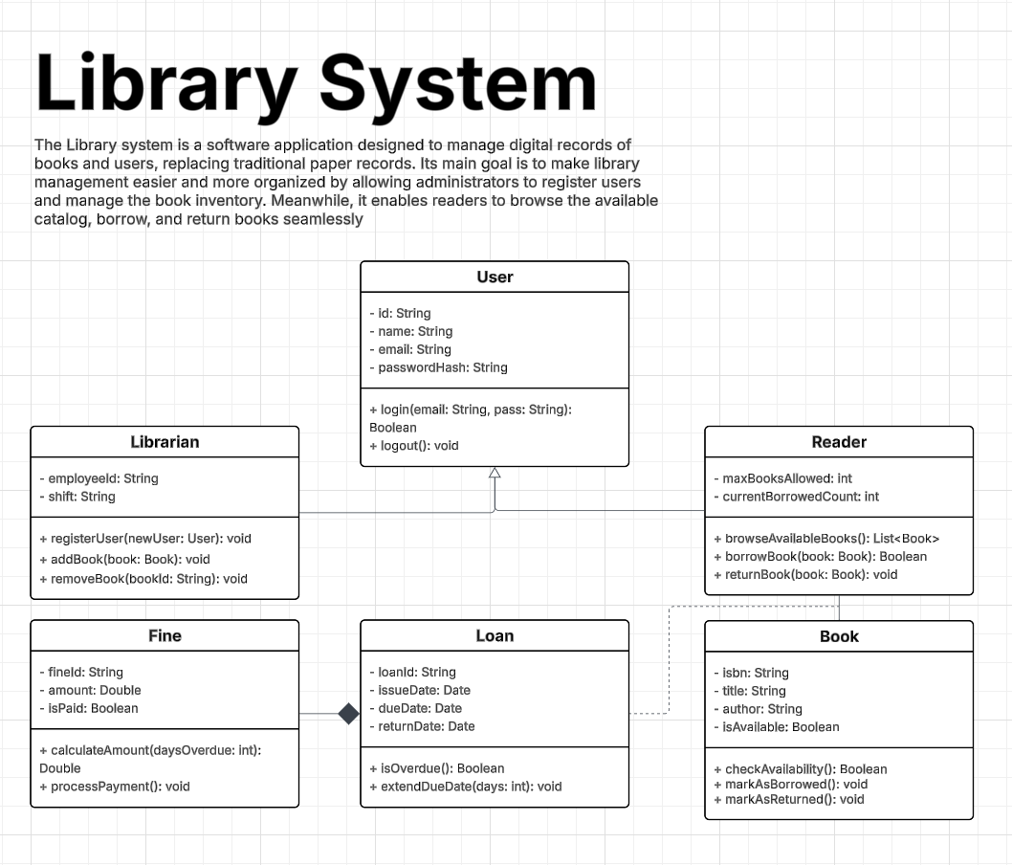
This Class Diagram defines the static structure of the Library System by outlining its core entities, attributes, and methods. At the center is the User base class, which branches into specialized Librarian and Reader subclasses through inheritance. The Book class stores essential details like ISBN and availability status, while the Loan class tracks borrowing periods and due dates. Additionally, a Fine class is strictly associated with the Loan entity to manage penalties for overdue returns. Together, these classes establish the underlying data model required to handle library inventory and user transactions.
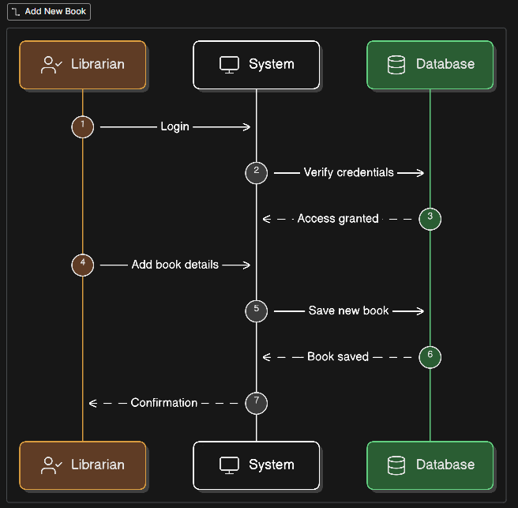
This Sequence Diagram details the step-by-step chronological interactions required to add a new book to the library's inventory. The flow begins with the Librarian interacting with the System GUI to initiate a login request. Once the backend Database verifies the credentials and grants access, the Librarian inputs the new book details. The System then forwards this structured data to the Database to be saved permanently. Finally, the Database confirms the successful entry, and a confirmation message is returned to the Librarian, completing the process.

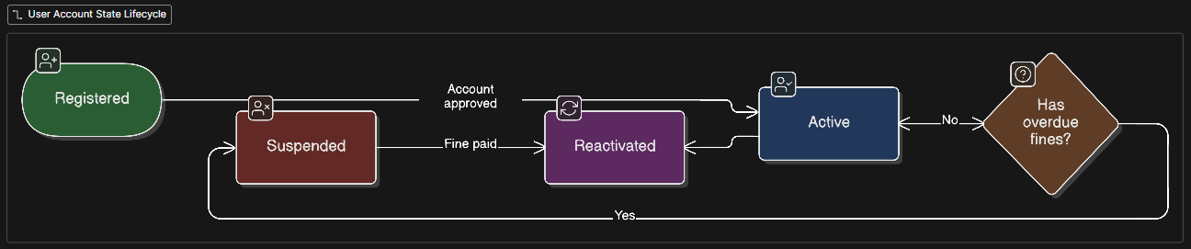
This State Diagram visualizes the lifecycle and the various operational conditions of a user's account within the system. An account begins in the initial "Registered" state and transitions to "Active" once the system or administrator approves it. If a user accumulates overdue fines, the system evaluates this condition and immediately shifts the account into a "Suspended" state, restricting borrowing privileges. Once the user pays the outstanding fine, the account moves to "Reactivated" and then transitions back to "Active." This dynamic ensures that users must resolve their penalties before continuing to use core library services.

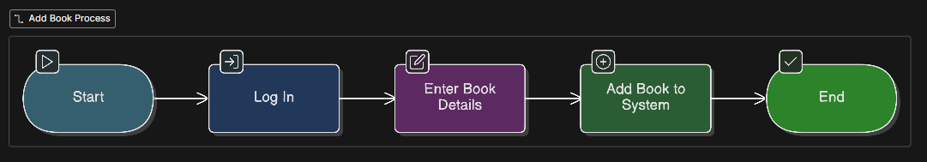
This Activity Diagram provides a high-level, flowchart-style overview of the workflow for adding a new book. The process initiates at the starting node and immediately requires the user, presumably a Librarian, to log into the system. Following a successful login, the user proceeds to the "Enter Book Details" action node to input necessary metadata like title and author. Next, the "Add Book to System" step executes the actual catalog update. The workflow then safely reaches the final endpoint, concluding a straightforward, linear operation without any complex branching.

